SECURITY FEATURES OF ATM

Sanam Jena

Stevens Institute of Technology

Author Note

Sanam Sritam Jena, Student at Stevens Institute of Technology

This research project is being presented as a part of evaluation & fulfilment of the curriculum of CS-550 Computer Organization & Programming under the guidance of

Dr. Edward Banduk.

Correspondence concerning to this article should be addressed to Sanam Jena,

Stevens Institute of Technology, Hoboken, NJ 07030.

Contact: sjena@stevens.edu

Abstract

The development in electronic exchanges has caused a additional noteworthy interest for fast and actual consumer characteristic proof and validation. Access codes for structures, ledgers and computer frameworks oftentimes utilize individual ID numbers (PIN's) for recognizable proof and trusty standing. a normal technique for recognizable proof keen about possession of ID cards or information measure sort of a government-managed savings variety or a secret key's not altogether solid. associate degree planted distinctive mark biometric validation conspire for cash dispenser Machine (ATM) banking frameworks is projected during this paper. within the course of recent decades, purchasers are to an excellent extent relying upon and basic cognitive process the automated Teller Machine (ATM) to helpfully meet their money wants. even so, no matter the varied focal points of the ATM framework, ATM deception has as recently gotten progressively across the board. during this paper, we have a tendency to offer a top level view of the conceivable deceitful exercises that may be dead against ATMs and explore prescribed ways in which to agitate forestall these forms of cheats. Specifically, we have a tendency to build up a model for the employment of bioscience ready ATM to allow security arrangements against the bulk of the outstanding breaks, from a yankee purpose of read. to ensure that such a security approach are going to be acknowledged by most of the shoppers, our model was tried and also the clients' conclusions got.

*Keywords:* Automated Teller Machines (ATMs), Personal Identification Number (PIN)

SECURITY FEATURES OF ATM

1. **Introduction**

The fast advancement of banking innovation has changed the manner in which banking exercises are managed. One financial innovation that has affected emphatically and adversely to banking exercises and exchanges is the coming of Automated Teller Machines (ATMs). With an ATM, a client can direct a few financial exercises, for example, money withdrawal, cash move, covering telephone and power tabs past available time and physical Interaction with bank staff. More or less, ATM gives clients a fast and advantageous approach to get to their ledgers and to direct money related exchanges. A Personal Identification Number (PIN) or secret word is one significant part of the ATM security framework. Stick or secret word is usually used to verify and shield money related data of clients from unapproved get to [10]. An ATM (referred to by different names, for example, a robotized banking machine, money point, money machine or an opening in the divider) is a mechanical framework that has its underlying foundations inserted in the records and records of a financial establishment [10] [13].

It is a modernized machine intended to administer money to bank clients without the need for human connection; it can move cash between ledgers and give other essential monetary administrations, for example, balance requests, smaller than normal proclamation, withdrawal and quick money among others [5]. The familiar axiom puts need as the mother of creation, however in this day and age, the relationship is some of the time switched. Mechanical advances regularly start things out and drive the quest for business applications. This circumstance is valid in the field of biometric distinguishing proof, whereby the robotized ID of individuals by natural attributes, for example, their fingerprints or iris designs. In the previous two years, quickly diminishes in cost and better execution have made biometric innovation down to earth for purchaser applications, for example, getting to programmed teller machines (ATMs) and for legislative purposes, for example, affirming the characters of welfare beneficiaries.

In any case, a sharp discussion is rising about whether biometric innovation offers society any huge points of interest over regular types of recognizable proof, and whether it comprises a risk to security and a potential weapon in the hands of dictator governments. The utilization of organic highlights for distinguishing proof is obviously not new—fingerprinting was created in the nineteenth century—nor is mechanization of the procedure. Starting in the late 1970s, safeguard and national security offices that could manage the cost of it began utilizing programmed biometric frameworks to check ways of life as a progressively secure option in contrast to picture IDs. However, increasingly broad applications didn't develop until more prominent registering power dropped the cost of biometric frameworks.

For instance, a unique mark scanner that costs $3,000 five years back, with programming included, and $500 two years prior, costs $100 today. Comparable value decreases have happened in other driving biometric advancements, for example, iris scanners. With lower costs, biometric ID frameworks are moving into two primary application territories—banking and administrative offices—and they have prodded development in the new business to almost $250 million per year in yearly deals. A few banks the world over, including Bank United (Houston, TX) and Nationwide Building Society in the United Kingdom have tried iris scanners as an option in contrast to individual recognizable proof number (PIN) codes for ATM get to. On a bigger scale, the province of Connecticut started to utilize unique finger impression examining in 1996 as a manner to recognize welfare beneficiaries, and the U.S. Armed force, Air Force, and Social Security Administration are taking a gander at different biometric acknowledgment frameworks. Both the Department of Defense and the Department of Veterans Affairs intend to utilize finger pictures to check the personality of representatives and those looking for retirement benefits.

On account of banking, the benefits of biometric scanners are essentially comfort as opposed to security. ―Customers like the simplicity of simply going up to the ATM and gazing at it for a couple of moments. In spite of the fact that biometric innovation secures against a hoodlum who can figure an indiscreetly picked PIN code, it does nothing to avoid the more typical burglaries in which an ATM client is burglarized close to the machine or constrained at gunpoint to pull back cash. The points of interest for government organizations are more clear, as biometrics make the making of bogus personalities harder. In any case, this is unequivocally what concerns some security and endeavors are in progress to create programmed signature distinguishing proof and voice-recognizable proof frameworks.

In this paper, we accordingly give a diagram of the conceivable fake exercises that might be executed against ATMs and examine prescribed ways to deal with averting these kinds of cheats. Specifically, we build up a model for the use of biometrics prepared ATM to give security arrangements against the vast majority of the notable ruptures. Apparently, ATMs in the Banking Industry of United States of America are not biometrically prepared, which makes our goals for this examination paper a need.

1. **Problem Statement**

Previously, money withdrawal, money store and financial balance subtleties of clients through financial exercises were exceptionally extreme and dreary, however, these days different banks have executed electronic financial exercises that enable clients to utilize the ATM since it's financial comforts in connection to the above exercises. Numerous banks worldwide have introduced ATMs in different spots/urban communities/towns/rustic territories so clients of banks can without much of a stretch pull back money and check their adjust and play out some other financial exchange with ATMs.

In any case, clients/clients of such electronic exchanges have numerous passwords used to get to their messages, vehicle radios, cell phones, PCs, ATM Cards and so on and clients have numerous cards like Credit Card, Debit Card, and Identity Card and so on. Hence, numerous issues are looked at by clients in connection to their ATM Cards and PINs, a portion of these issues are explained beneath:

Once in a while a ton of exertion is included when clients/clients are required to recall various passwords. On numerous events, clients overlook their passwords. Overlooking passwords at times make an issue of not playing out a necessary exchange and contributing incorrectly secret key will probably prompt hacking/seizure/locking of the ATM card. ATM cards must be versatile so as to be utilized. Neglect of ATM cards at the purpose of exchange will consistently yield no exchanges and negative outcomes.

Occasionally clients/client utilize a typical PIN/secret key for every electronic exchange thing. In such cases, there are shortcomings and insufficiency of security, in light of the fact that whatever other individuals who know a typical secret phrase of another can without much of a stretch utilize his/her ATM card. So as to annihilate these kinds of inadequacies, we propose the ATM machine with the biometric framework. Different biometric advancements, for example, iris, finger, voice, wrist and so forth are right now being utilized on a worldwide scale in creating nations. Every client has a novel personality dependent on physical or conducts qualities. These properties are never taken by any individual.

**3. Types of ATM Frauds**

Over the most recent couple of years, there have been numerous reports of hacking into the electronic ATM framework and this has caused misfortunes of billions of dollars in the worldwide financial industry. Prophet assault on validation conventions and ruptures influencing ATMs, for example, cloning of cards and hacking of PIN code have been progressively been accounted for. Some famous ATM fakes/assaults are clarified in the subsections underneath.

***I. Skimming Attacks***

This is the most well-known rupture in ATM exchange. In this clever sham, crooks are exploiting innovation to make fake ATM cards by utilizing a skimmer (a card swipe gadget that peruses the data on ATM card). These gadgets take after a handheld charge card scanner and are frequently secured in closeness to or over the highest point of an ATM's production line introduced card peruser. At the point when expelled from the ATM, a skimmer permits the download of individual information having a place with everybody who utilized it to swipe an ATM card. A solitary skimmer can hold data from than 200 ATM cards before being re-utilized.

***II. Card Trapping***

This includes setting a gadget straightforwardly finished or into the ATM card peruser opening. For this situation, a card is physically caught by the catching gadget inside the ATM. At the point when the client leaves the ATM without their card, the card is recovered by hoodlums/offenders. Normally just one card is lost in each assault. The most widely recognized variation is known as the Lebanese Loop.

***III. Pin Cracking***

Assaults on clients 'PINs have been known to security specialists for quite a long time, e.g., [3], [9], [7]. One of the most proficient of these PIN cracking' attacks was examined in [8]. How the preparing framework utilized by banks is available to manhandle was clarified in [8]. One of the assaults focuses on the decipher work in switches - a maltreatment work that is utilized to enable clients to choose their PINs on the web. In either case, the defects make a method for an assailant to find PIN codes, for instance, those entered by clients while pulling back money from an ATM gave them to approach the online PIN check office or exchanging forms. A bank insider could utilize a current Hardware Security Module (HSM) to uncover the encoded PIN codes.

***IV. Phishing/Vishing Attack***

In the direst outcome imaginable, an insider of an outsider exchanging supplier could assault a bank outside of his domain or even in another mainland. Shockingly, recommendations to counter such assaults are practically nonexistent other than a couple of proposals; for instance, keeping up the mystery (and uprightness) of certain information components identified with PIN preparing (that are viewed as security harsh as indicated by flow banking norms, for example, the decimalization table' and PIN Verification Values (PVVs)/Offsets' have been underlined [9], [8].

Phishing tricks are intended to allure the client to give the card number and PIN for their bank card. Ordinarily, an aggressor utilizes email speaking to them as a bank and guaranteeing that client account data is fragmented, or that the client needs to refresh their record data to keep the record from being shut. The client is approached to tap on a connection and pursue the headings gave. The connection anyway is false and guides the client to a site set up by the assailant and intended to resemble the client's bank. The site guides the client to include delicate data, for example, card numbers and PINs. The data is gathered by the cheats/offenders/programmers and used to make deceitful cards. A few variations are skewer phishing and Rock Phish assaults.

Generally, after an effective phishing assault, the criminal would separate the required data and go into the online record and expel the unfortunate casualty's bank reserves. This has changed for a portion of the more refined hoodlums as of late were as opposed to plundering the injured individual's record; they go to the check picture page, where they take a duplicate of the unfortunate casualty's check. Numerous money related foundations are presently offering check pictures as a component of their web-based financial administrations to their clients. The checks contain the injured individual's ledger number, signature, address, telephone and so on. The aggressor can either take the duplicate and make paper fake checks or take that data and make PayPal accounts or other online installment accounts that will leave the injured individual on the snare for any buys.

***V. ATM Malware***

Malware assaults require an insider, for example, an ATM expert who has a key to the machine, to introduce the malware on the ATM. When that has been done, the aggressors can embed a control card into the machine's card peruser to trigger the malware and give them control of the machine through a custom interface and the ATM's keypad. As indicated by a report in [11], a Trojan group of malware contaminated 20 ATMs in Eastern Europe. The malware gives culprits a chance to assume control over the ATM to take information, PINs, and money. The malware catches attractive stripe information and PIN codes from the private memory space of exchange handling applications introduced on an undermined ATM.

***VI. ATM Hacking***

Assailants utilize advanced programming systems to break into sites that live on a monetary foundation's system. Utilizing this entrance, they can get to the bank's frameworks to find the ATM database and subsequently gather card data which can be utilized later to make a clone card. Hacking is likewise regularly used to depict assaults against card processors and different segments of the exchange handling system. The greater part of the ATM Hackings is because of the utilization of non-secure ATM programming.

***VII. Physical Attacks***

ATM physical assaults are endeavored on the safe inside the ATM, through mechanical or warm means with the aim of breaking the safe to gather the money inside. Probably the most well-known strategies incorporate slam assaults, touchy assaults, and cutting. Burglary can likewise happen when ATMs are being renewed or adjusted. Staff is either held up as they are conveying cash to or from an ATM or when the ATM safe is open and money tapes supplanted. There is an assortment of mechanical and physical components that can hinder assaults to the safe. The affirmation level of the safe (UL 291 Level 1 is suggested as a base for ATMs set in unbound, unmonitored areas). Alerts and sensors that will recognize physical assaults on the ATM safe. Ink stains advancements that will run and make unusable any evacuated banknotes.

**4. Security Measures of ATMS**

As innovation advances and ATM applications become progressively omnipresent, there is a greater amount of classified information being transmitted over the ATM framework. As progressively delicate exchanges are led, more dangers breaks are accounted for and the test of verifying the framework turns out to be increasingly earnest. Numerous security benefits in bank exchanges are subject to confirming clients, for example, age of exact review trails, non-revocation in correspondences, safeguarding classification and other info approval strategies, for example, bunch sums, design checks, sensibility checks, and exchange approval.

These highlights just guarantee that specific methods are pursued and can't tell whether the individual with the card and PIN is approved to utilize it, they simply guarantee that the information transmitted pursues certain rules or conventions that solicitation exchanges, for example, money withdrawals are made inside sensible limits, that cash is moved to the best possible record, etc. Along these lines, it is fundamental to create more grounded validation and distinguishing proof measures to prevent crooks from submitting deceitful acts.

***I. Electronic Banking System***

Electronic financial which is a rising worldview in United States of America is another industry that enables individuals to collaborate with their financial records by means of the Internet from for all intents and purposes anyplace on the planet. The electronic financial framework tends to a few rising patterns: client interest for whenever, anyplace administration, item time-to-showcase objectives, and progressively complex back-office coordination challenges. This framework enables purchasers to get to their financial records, survey the latest exchanges, demand a present proclamation, move reserves, see current bank rates and item data and reorder checks. E-banking can be characterized as the arrangement of banking administrations and items over electronic and correspondence organize legitimately to clients [7].

It is the mechanized conveyance of new and conventional financial items and administrations legitimately to clients through electronic, intuitive correspondence channels [8]. These electronic and correspondence systems incorporate Automated Teller Machines (ATMs), direct dial-up associations, private and open systems, the Internet, TVs, cell phones and phones. Among these advancements, the expanding entrance of PCs, moderately simpler access to the Internet and especially the more extensive dissemination of cell phones have drawn the consideration of most banks to e-banking. Critical contrasts exist among banks regarding their ebanking capacities.

***II. Strengths and Advantages of Biometric Technology***

Biometric innovation identifiers are hard to be lost or overlooked, hard to be duplicated/mutual and require the individual to be validated to be available at the time and purpose of confirmation (a client can't guarantee his secret key was taken and misused!!). Rather than passwords, biometric frameworks could be utilized to secure the solid cryptographic keys. A few qualities of biometric innovation incorporate the accompanying:

Arrangement of solid validation. It can be utilized rather than a PIN. Covered up or decreased expenses of ATM card the board like card personalization, conveyance, the executives, re-issuance, PIN age, help work area, and re-issuance can be maintained a strategic distance from. It is precise. The adaptable record gets to enable customers to get to their records whenever the timing is ideal. The operational expense of the ATMs will at last diminish. For a given biometric identifier, all clients have a generic equivalent security level – One client's biometrics are no simpler to break than another's. There can't be numerous clients who have ―easy to guessǁ biometrics that can be utilized to mount an assault against them. The usually utilized biometrics are DNA, Face, Ear, Facial infrared thermogram, Fingerprint, Gait, Hand and Finger geometry, Iris, Keystroke, Palm prints, Signature, Voice and so on which are altogether different among people [2]. The benefits of the biometric coordinated frameworks in ATMs are:

This biometric incorporated arrangement of ATM is more secure than the ordinary ATM framework. It perceives the real record holder no one other than the card holder can work the ATM. It tends to be just worked by the genuine record holder. It gives wellbeing and security to the Bank account holders .It is 100% temper verification. It gives 100% security to the ATM cardholders. On the off chance that anybody acquires the stick number and different subtleties of the ATM cardholder and, after its all said and done it can't be worked except if the thumb impression is coordinated. Biometric coordinated frameworks in ATMs can be utilized in Visas and check cards and other online installment frameworks. The bank will likewise lean toward this framework with the perspective of security and client care. Biometric incorporated frameworks in ATMs will decrease the remaining task at hand of the banks Biometric coordinated frameworks in ATMs will expand the trust of the financial client. Biometric coordinated frameworks in ATMs can likewise be actualized with the CCTV reconnaissance and Alarms Bells to dodge the tear open of the ATM Machine by the criminals. Biometric incorporated frameworks in ATMs are valuable to the uneducated individual and for provincial zones. With the mix of the PIN and biometric framework, the ATM exchange is completely verified. Biometric incorporated frameworks in ATMs will limit the odds of the blockage of record by virtue of the wrong stick utilized by the ATM cardholder.

**5. Related Work**

Shaikh and Rabaiotti [8] broke down the United Kingdom (UK) Identity (Id) Card conspire. Their investigation moved toward the plan from the point of view of high volumes of open organization and they depicted an exchange off triangle model. They found that there are exchange offs between a few attributes, for example, precision, security, and versatility in a biometric-based character the board framework, where the accentuation on one undermines the other. A Murthy and Reddy [3] built up an installed unique mark framework, which is utilized for ATM security applications. In their framework, investors gather clients' fingerprints and versatile numbers while opening records, and afterward clients just access the ATM. The ATM works so that each time a client puts his/her finger on the printing module, the ATM consequently produces an alternate 4-digit code as a message to the cell phone of the approved client through a GSM modem associated with the microcontroller. The code got by the client is gone into the ATM machine by squeezing the keys on the touch screen. In the wake of entering the got code, the ATM checks whether the code is legitimate or not previously permitting the client further access and utilization. Schouten and Jacobs [7] introduced an assessment of the Netherlands' proposed execution of a biometric identification, generally concentrating on specialized parts of explicit biometric advancements, (for example, face and unique mark acknowledgment) yet in addition settling on reference to universal understandings and benchmarks, (for example, ICAO and the EU's Extended Access Control'') and examined the protection issue as far as customary security ideas, for example, classification. Debbarma [10] proposed an inserted Crypto Biometric confirmation plot for the ATM banking framework.

The improvement and arrangement period of the Belgium e-ID card has been examined by Marein and Audenhove (2010). It has been contended that the preexistence of the national register was one of the elements that have helped in the improvement of the Belgium e-ID card. So far 8,000,000 cards have been given to Belgium residents referencing the procedure was smooth and direct (Marein and Audenhove, 2010). A discourse on security and the plan of the Malaysian character card, i.e., Mykad has been finished by Raphael et al. (2003). Mykad incorporates an ID card, driving permit, visa, and ATM. Since Mykad is utilized for different touchy purposes, Raphael et al. (2003) expressed that its security highlights ought to be broken down before it is conveyed. It is imperative to think about the recognition and reaction of end clients while creating and breaking down biometric-based character the executive's frameworks (Laurie et al., 2007).

**6. Research Design and Methodology**

The security highlight for upgrading the Indian Banking ATM was planned to utilize the customer/server design. In this situation, there is an association between the client's recognizable proof data, client's records and records in the bank (server). The system is intended to help countless clients and utilizations committed server to achieve this. The explanation behind picking a Client/Server model for our proposed framework is on the grounds that it gives satisfactory security to the assets required for a basic application, for example, banking frameworks. So also, a graphic applied methodology that incorporates Unified Modeling Language (UML) devices, for example, use case models, action charts and arrangement outlines and so on is adjusted. The work is executed utilizing Visual Basic 6.0 programming instruments, used to structure the UIs and additionally cardholder communication with the ATM Machine.

**7. Proposed Biometric (Fingerprint) Strategy for American Banking System**

Outstanding amongst other safety efforts against a portion of the assaults referenced above is the sending of biometrics in the present ATM framework as talked about beneath.

Biometric Smartcard – A model

Biometric recognizable proof is used to check an individual's personality by estimating carefully certain human qualities and contrasting those estimations and those that have been put away in a format for that equivalent individual. Layouts can be put away in the biometric gadget, the organization's database, a client's savvy card, or a Trusted.

Outsider specialist organization's database. There are two significant classes of biometric methods: physiological (unique finger impression confirmation, iris examination, hand geometry-vein designs, ear acknowledgment, smell discovery, DNA design investigation and sweat pore examination), and conduct (written by hand signature check, keystroke examination and discourse examination). In [12], it was discovered that conduct based frameworks were seen as less satisfactory than those dependent on physiological attributes. Of the physiological systems, the most regularly used is that of unique finger impression examining. With biometrics, such false occurrences can be limited, as an additional layer of verification is presently presented that guarantees that even with the right stick data and possessing someone else's ATM card, the client's biometric highlights can only with significant effort be faked.

In banking framework Biometrics holds the guarantee of quick, simple to-utilize, precise, dependable, and more affordable validation for an assortment of uses [2]. At the hour of exchange clients enlistment their unique mark to a high goals finger impression scanner. The unique finger impression picture is transmitted to the focal server by means of verified channel. At the financial terminal the details extraction and coordinating are performed to confirm the displayed unique mark picture has a place with the asserted client in bank database. The validation is marked if the details coordinating are effective. The proposed plan is quick and progressively secure. Fig 1 shows the entire strategies for proposed banking biometric application framework in India. A fundamental biometric validation framework comprises of five primary parts.

These are: sensor, highlight extractor, unique mark/layout database, and matcher and choice module. The capacity of the sensor is to examine the biometric characteristic of the client. The capacity of the component extraction module is to remove the list of capabilities from the examined biometric quality. This list of capabilities is then put away into the layout database. The matcher modules take two sources of info, for example highlight sets from the layout database and list of capabilities of the client who needs to verify him and looks at the likeness between the two sets. The last module, i.e., the check module settles on the choice about the coordinating of the two capabilities. Biometrics is a quickly advancing innovation that is as a rule broadly utilized in legal sciences, for example, criminal recognizable proof and jail security, and that can possibly be utilized in a huge scope of regular citizen application regions. Biometrics can be utilized to anticipate unapproved access to ATMs, mobile phones, brilliant cards, work area PCs, workstations, and PC systems.

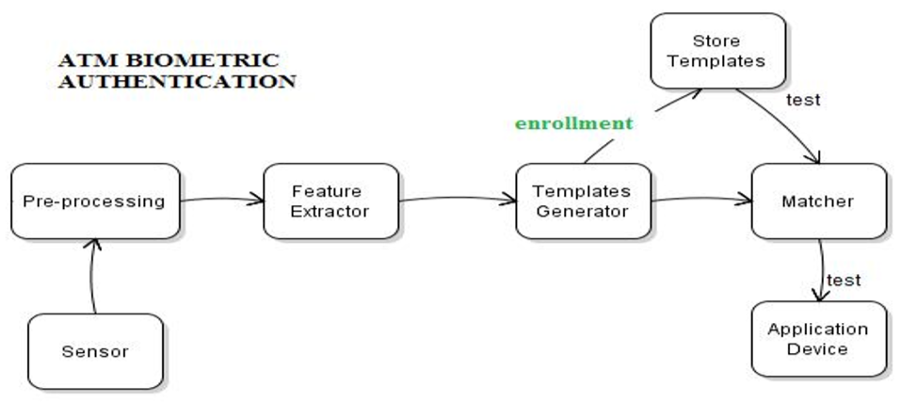

**Fig 1: Working of Biometric Authentication**

Figure 1 above shows the working of the biometric confirmation process. A biometric gadget takes a shot at the premise of some human attributes, for example, unique finger impression, voice or patter of the line in the iris of your eye. These gadgets incorporate impression locators, voice recognizers and distinguishing proof patter in the retina. Verification with such gadgets utilizes unpardonable physical attributes to verify clients. The client database contains an example of a client's biometric attributes. During validation, the client is required to give another example of the client's biometric attributes. This is coordinated with the one in the database, and in the event that the two examples are the equivalent, at that point, the client is viewed as a substantial client. The benefits of this may include: all characteristics of the ATM cards will be kept up, duplicating endeavors are decreased because of the enlistment process that checks personality and catches biometrics, and it will be amazingly high security and astounding client to-card verification. These focal points are to serve clients just as framework heads in light of the fact that the issues and expenses related to lost, reissued or briefly gave can be stayed away from, in this manner sparing a few expenses of the framework the executives. On the negative side, the significant hazard presented by the utilization of biometric frameworks is that a pernicious subject may meddle with the correspondence and block the biometric layout and use it later to acquire get to [4]. In like manner, an assault might be submitted by producing a layout from a unique mark that got from some surface. Albeit few biometric frameworks are quick and exact as far as low bogus acknowledgment rate enough to permit distinguishing proof (consequently perceiving the client character), a large portion of the present frameworks are reasonable for the check just, as the bogus acknowledgment rate is excessively high.

The proposed configuration utilizes a limit of 8 characters, numbers or a blend of both PIN and unique mark as confirmation elements of the validation procedure. ACOS smartcards and AET60 BioCARD Key advancement packs were utilized in the proposed structure. In the confirmation part, the clients need to present the right PIN DES scrambled current session key to gain admittance to the following level. Clients have 3 effective endeavors to enter the right PIN, else the cards will be bolted and render it to futility. In conclusion, we utilize the unique finger impression as the biometric identifiers as it requires some investment.

Dependable, client confirmation is turning into an inexorably significant assignment in the Web-empowered world. The results of an uncertain validation framework in a corporate or undertaking condition can be calamitous, and may incorporate loss of secret data, refusal of administration, and traded off information trustworthiness. The estimation of dependable client confirmation isn't constrained to simply PC or system get to. Numerous different applications in regular day to day existence additionally require client confirmation, for example, banking, web-based business, and physical access control to PC assets, and could profit by improved security.

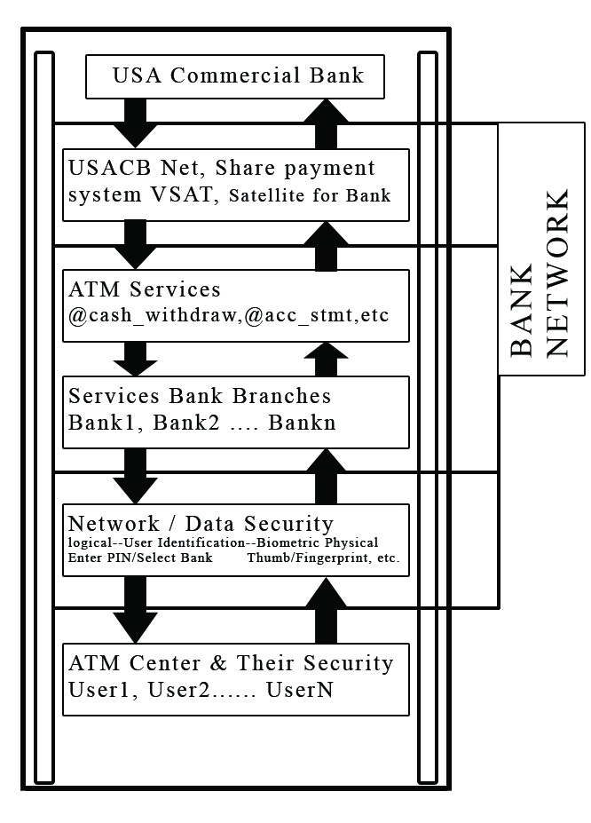

**Fig 2: Conceptual ATM Model**

The common strategies of client validation, which include the utilization of either passwords and client IDs (identifiers) or distinguishing proof cards and PINs (individual ID numbers), experience the ill effects of a few impediments. Passwords and PINs can be illegally procured by direct secretive perception.

When a gatecrasher gains the client ID and the secret word, the interloper has all-out access to the client's assets. Furthermore, there is no real way to decidedly connect the utilization of the framework or administration to the genuine client, that is, there is no assurance against renouncement by the client ID proprietor. For instance, when a client ID and secret key is imparted to an associate there is no chance to get for the framework to know who the genuine client is. A comparable circumstance emerges when an exchange including a Mastercard number is directed on the Web. Despite the fact that the information is sent over the Web utilizing secure encryption techniques, current frameworks are not equipped for guaranteeing that the exchange was started by the legitimate proprietor of the charge card. In the cutting edge circulated frameworks condition, the conventional verification approach dependent on a basic mix of the client ID and secret word has gotten lacking. Luckily, robotized biometrics all in all, and unique finger impression innovation specifically, can give a significantly more precise and solid client confirmation strategy. Biometrics is a rapidly moving field that is stressed over perceiving an individual subject to their physiological or social characteristics.

Biometric readings, which go from two or three hundred bytes to over a megabyte, have the bit of room that their information content is regularly higher than that of a mystery word or a pass articulation. Essentially loosening up the length of passwords to get practically identical piece quality presents vital convenience issues.

It is practically hard to remember a 2K articulation, and it would put aside an annoyingly long

exertion to type such an articulation (especially without bungles). Fortunately, mechanized biometrics can give the security focal points of long passwords while holding the speed and trademark straightforwardness of short passwords.

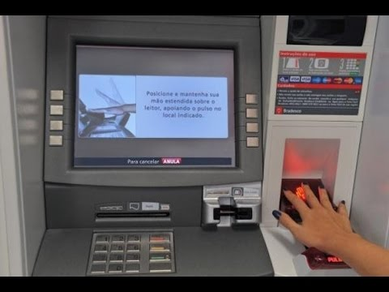

**Fig 3: Biometric ATM**

Despite the fact that robotized biometrics can help ease the issues related with the current strategies for client confirmation, programmers will at present discover there are frail focuses in the framework, powerless against assault. Secret word frameworks are inclined to animal power lexicon assaults. Biometric frameworks, then again, require generously more exertion for mounting such an assault. However there are a few new sorts of assaults conceivable in the biometrics space. This may not have any significant bearing if biometrics is utilized as a directed validation device. Be that as it may, in remote, unattended applications, for example, Web based internet business applications, programmers may have the chance and sufficient opportunity to cause a few endeavors, to or even physically disregard the respectability of a remote customer, before recognition.

An issue with biometric verification frameworks emerges when the information related with a biometric include has been undermined. For validation frameworks dependent on physical tokens, for example, keys and identifications, an undermined token can be effectively dropped and the client can be relegated another token. Also, client IDs and passwords can be changed as frequently as required. However, the client just has a predetermined number of biometric highlights (one face, ten fingers, and two eyes). On the off chance that the biometric information are undermined, the client may immediately come up short on biometric highlights to be utilized for verification. Wrongdoing at ATMs has become an across the nation issue that countenances clients, yet in addition bank administrators and this money related wrongdoing case rises more than once as of late [1]. A great deal of crooks mess with the ATM terminal and take customers ‘card subtleties by unlawful methods. Once the users ‘bank card is lost and the secret phrase is taken, the users ‘account is helpless against assault. Conventional ATM frameworks verify by and large by utilizing a card (credit, charge, or shrewd) and a secret word or PIN which no uncertainty has a few deformities [2]. The common systems of client confirmation, which includes the utilization of either passwords and client IDs (identifiers), or recognizable proof cards and PINs (individual distinguishing proof numbers), experience the ill effects of a few restrictions [3]. Passwords and PINs can be illegally obtained by direct incognito perception. At the point when credit and ATM cards are lost or taken, an unapproved client can frequently think of the right close to home codes.

In spite of admonitions, numerous individuals keep on picking effectively speculated PIN's and passwords - birthday celebrations, telephone numbers and government managed savings numbers. Ongoing instances of data fraud have uplifted the requirement for strategies to demonstrate that somebody is genuinely who he/she professes to be. Biometric validation innovation may take care of this issue since an individual's biometric information is verifiably associated with its own, is nontransferable and special for each person. The framework can contrast examines with records put away in a focal or neighborhood database or even on a shrewd card. Biometrics can be characterized as a quantifiable physiological and conduct trademark that can be caught and in this way contrasted and another occurrence at the hour of check. It is mechanized strategies for perceiving an individual dependent on a physiological or social trademark [9]. It is a proportion of a person's one of a kind physical or social qualities to perceive or confirm its personality [7]. Basic physical biometric qualities incorporate unique finger impression, hand or palm geometry, retina, iris and face while well known conduct attributes are mark and voice. Biometrics advances are a safe methods for verification since biometrics information are one of a kind, can't be shared, can't be duplicated and can't be lost.

Biometric verification has become increasingly more well known in the banking and money area [13]. Fingerprint isn't just for security yet additionally to defeat the absence of client comprehension of ATM idea. We proposed ATM with biometric, a unique mark security framework, so as to address its clients' issues whom a significant number of them have an investment account and need to approach their cash during non-banking hours.

Worked utilizing just a brilliant card and a unique finger impression scanner, the machines offer superb security to card holders since there is a low probability of misrepresentation. In the event that a client loses the card, it is hard for someone else to utilize it due to the advanced unique mark. By utilizing unique mark acknowledgment clients are increasingly OK with setting aside their cash in the bank since they get that on the off chance that they lose their ATM card, nobody can reproduce their unique finger impression and take their cash. Unique mark confirmation is the most well known strategy among biometric validation, unique finger impression based recognizable proof is one of the most develop and demonstrated procedure [10].

As of late the Government of India additionally proposed assortments of Identity Card utilizing Biometric based applications. Other than this we can likewise utilize this system in various field Government or non-Government in various applications. A Unique Identification is simply a string doled out to an element that recognizes the element particularly. We intend to allot a Unique ID to each individual dwelling in India. Biometric recognizable proof framework and checks would be utilized to guarantee that every individual is doled out one and only UID and the way toward producing another UID would guarantee that copies are not given as substantial UID numbers [9]. As of late Government in India began a biometric based ID card for example Unique Identification Authority of India. Currently UID is being used to pull out the repayment score of people and offer on spot loans.

An inserted Crypto-Biometric confirmation plot for ATM banking frameworks is proposed in our paper. In this plan, cryptography and biometric methods are melded for individual confirmation to improve the security level [3].

**8. Conclusion**

ATM gives money related administrations to an expanding section of the populace in numerous nations. Unique mark examining keeps on picking up acknowledgment as a dependable recognizable proof and check form. This paper recognizes a model for the adjustment of existing ATM frameworks to monetarily consolidate unique finger impression checking PLUS blood gathering; and, diagrams the upsides of utilizing such a framework. It ought to be noticed that the customer's perception can't be summed up as it was profoundly influenced by the convention or culture of the clients includes

References

[1] ATM scam nets Melbourne thieves $500,00 (2009, March 24). Retrieved from

<https://community.fico.com/s/page/a5Q8000000082JeEAI/fico1014>..

[2] Australian police suspect Romanian gang behind $1 million ATM scam. (2009, April 13).

Retrieved from [https://www.atmmarketplace.com/news/australian-police-suspect-romanian-gang-behind-1-million-atm-scam/.](https://www.atmmarketplace.com/news/australian-police-suspect-romanian-gang-behind-1-million-atm-scam/)

[3] Krebs, B. (2016, February). Safeway Self-Checkout Skimmer Close Up. Retrieved November 21, 2019, from <https://krebsonsecurity.com/2016/02/safeway-self-checkout-skimmer-close-up/>.

[4] F. Deane, K. Barrelle, R. Henderson, & D. Mahar (2005) ―Perceived acceptability of biometric security systemsǁ. Computers & Security, Vol. 14, N. 3, pp. 225-231

[5] Global ATM Market and Forecasts (2013), Retrieved November 21, 2019, from [www.rbrlondon.com](http://www.rbrlondon.com)

[6] Luca, S. Bistarelli, S. &A. Vaccarelli, ―Biometrics authentication with smartcardǁ, IIT TR-. 08/2002

[7] M. Bond and P. Zielinski (2003) ―Decimalisation table attacks for PIN Crackingǁ, Technical report (UCAMCLTR-560), Computer Laboratory, University of Cambridge

[8] M. Bond and P. Zielinski (2004) ―Encrypted? Randomized? Compromised? (When cryptographically secured data is not secure)ǁ in Workshop on Cryptographic Algorithms and their Uses, Gold Coast, Australia

[9] M. Bond (2004) ―Understanding security APIsǁ Ph.D. Thesis, Computer Laboratory, University of Cambridge

[10] NetWorld Alliance, ―Timeline: The ATM's Historyǁ, 2003

[11] O. Berkman and O. M. Ostrovsky (2007) ―The unbearable lightness of PIN crackingǁ in Financial Cryptography and Data Security (FC), Scarborough, Trinidad and Tobago

[12] Munro, R., & Munro, R. (2009, June 5). Malware steals ATM accounts and PIN codes: TheINQUIRER. Retrieved November 21, 2019, from <https://www.theinquirer.net/inquirer/news/1184568/malware-steals-atm-accounts-pin-codes>.

[13] Gordon, C. (2018, July 16). A history of ATM innovation. Retrieved November 25, 2019, from <https://www.ncr.com/company/blogs/financial/history-atm-innovation>.

[14] Koteswari, S., Paul, P. J., Dheeraj, A., & Kone, R. (2016, November 11). Fusion of Iris and Fingerprint Biometric Identifier for ATM Services: An Investigative Study. Retrieved from https://www.scirp.org/journal/paperinformation.aspx?paperid=72220.